**Jenkins and Git Integration for Java Selenium**

1. **Add project to Git repository**
2. **Jenkins configuration for git project**

**Prerequisites:**

1. Maven project and pom.xml file
2. git.exe 🡪 download using URL = <https://git-scm.com/download/win>
3. jdk 1.8
4. Apache maven 3.6.3
5. GitHub repository URL
6. Jenkins setup with Jenkins.war file
7. Maven integration plugin (maven-plugin.hpi) 🡪 download from <https://updates.jenkins-ci.org/download/plugins/maven-plugin/>

**Add project to Git repository:**

Note: Create a new repository in GitHub and Copy URL from Github

Step 1) Right click on your maven project 🡪 Team 🡪 Share Project.

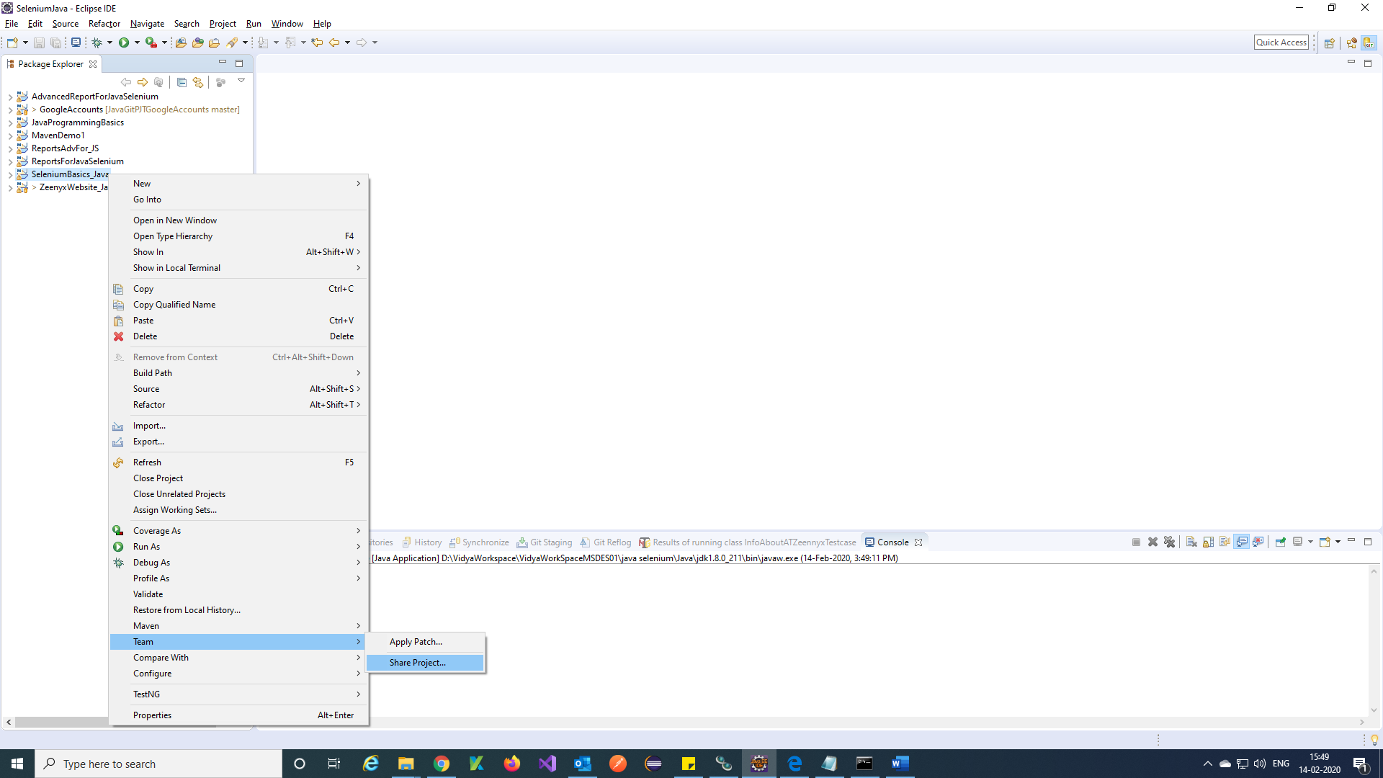

Step 2) Click on Create 🡪 Browse Path of Empty folder to place your project 🡪 Finish 🡪 Finish.

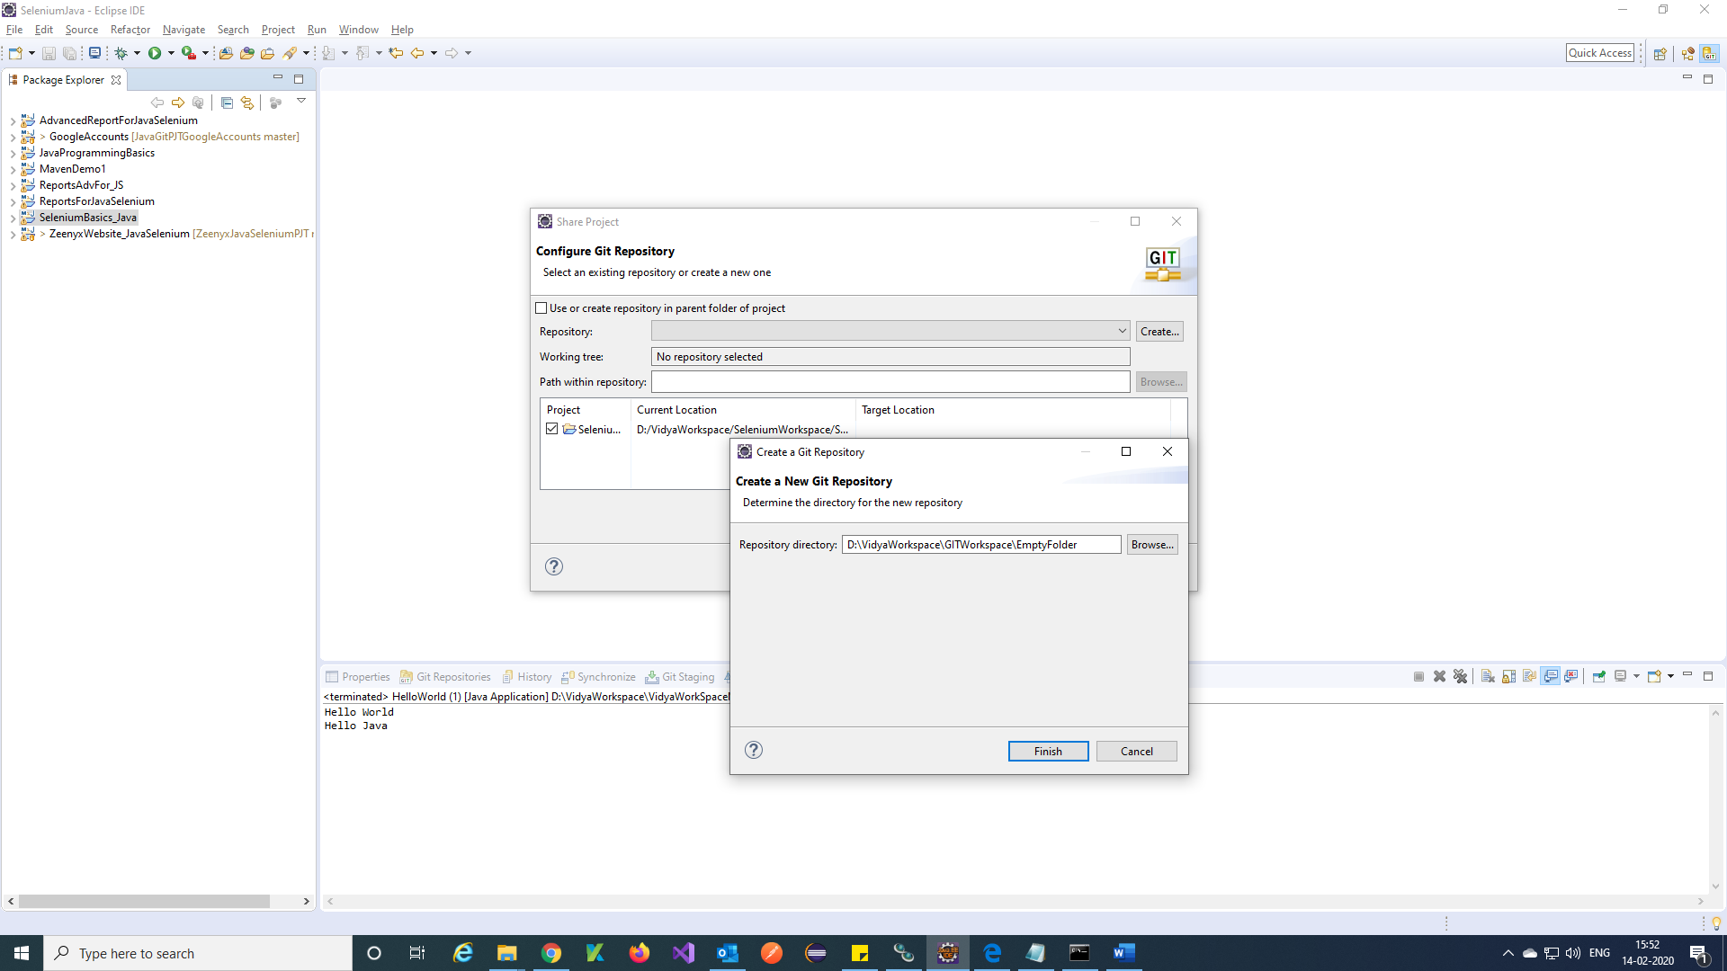

Step 3) Click on Window 🡪 Show View 🡪 Other.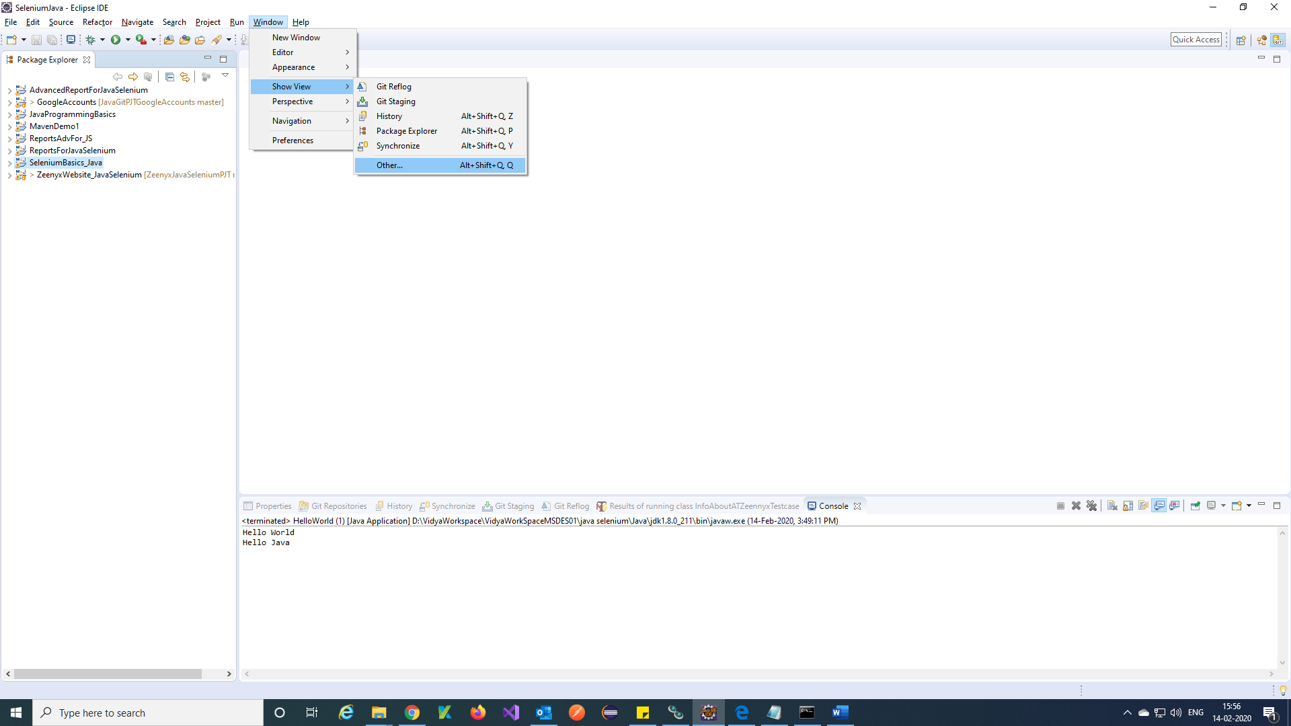

Step 4) Search git and Select Git Repositories 🡪 Open.

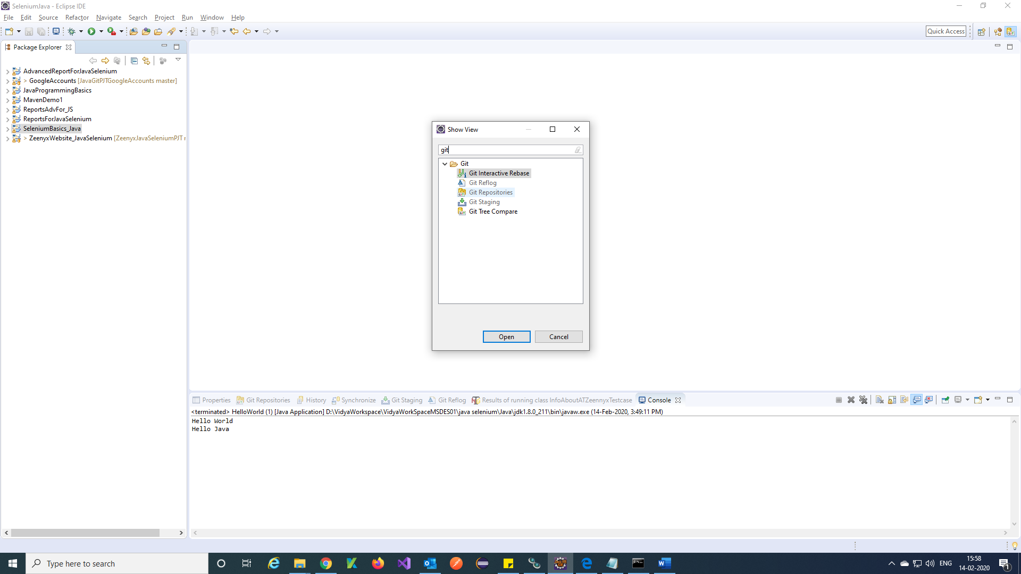

Step 5) You will get created repository for git.

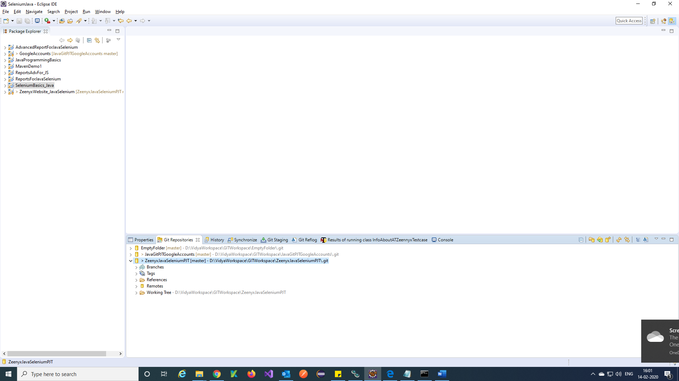

Step 6) Right click on project 🡪 Team 🡪 Commit.

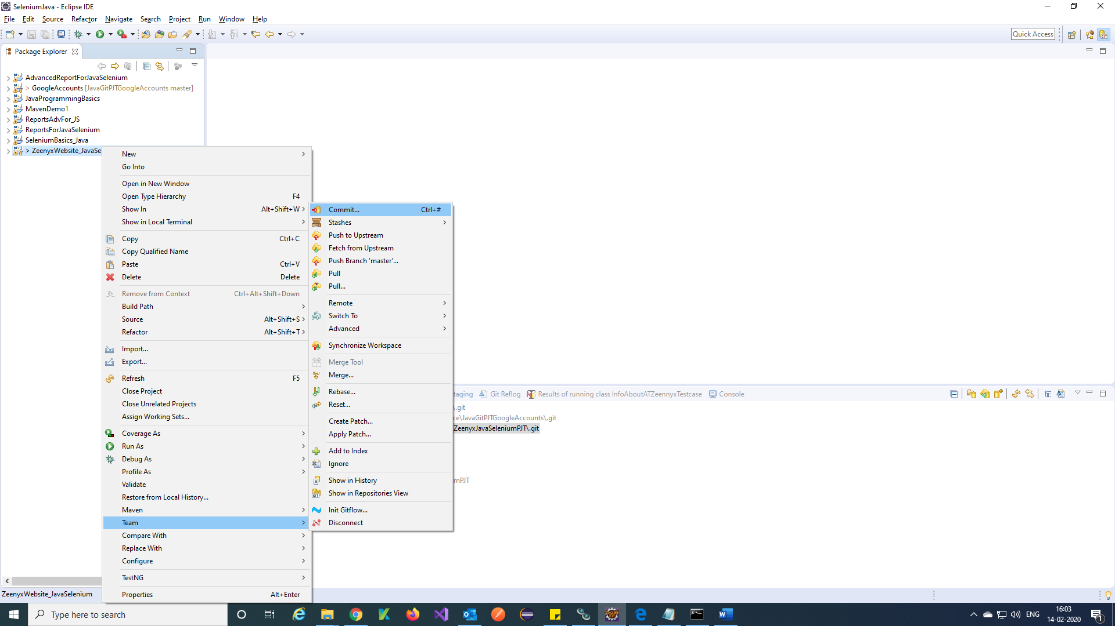

Step 7) Select all items 🡪 Right Click 🡪 Add to Index.

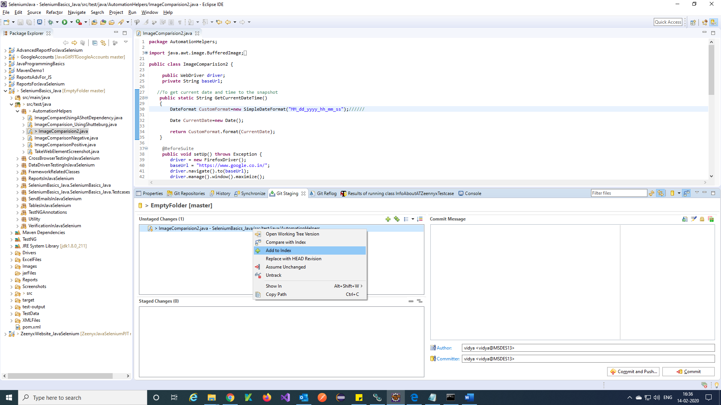

Step 8) All items added to Staged changes and Give commit message as any text 🡪 Commit and Push.

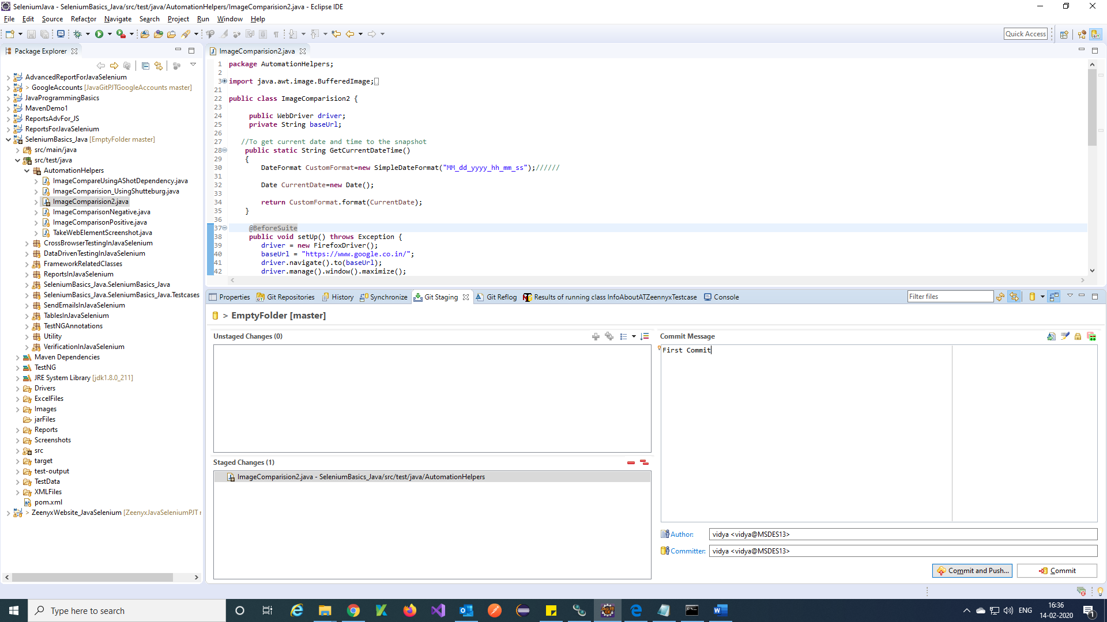

Step 9) Enter all the details like Git repo URL and GitHub account credentials 🡪 Next.

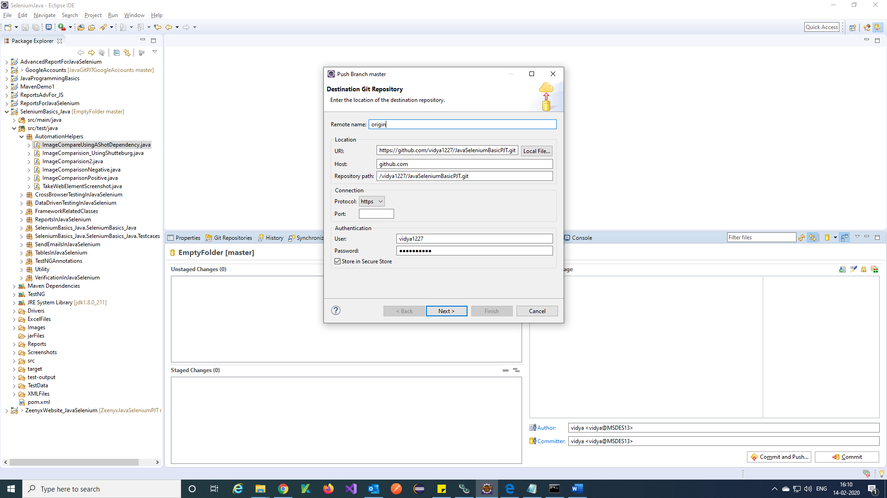

Step 10) Check the checkbox which is marked in the dialog 🡪 Next.

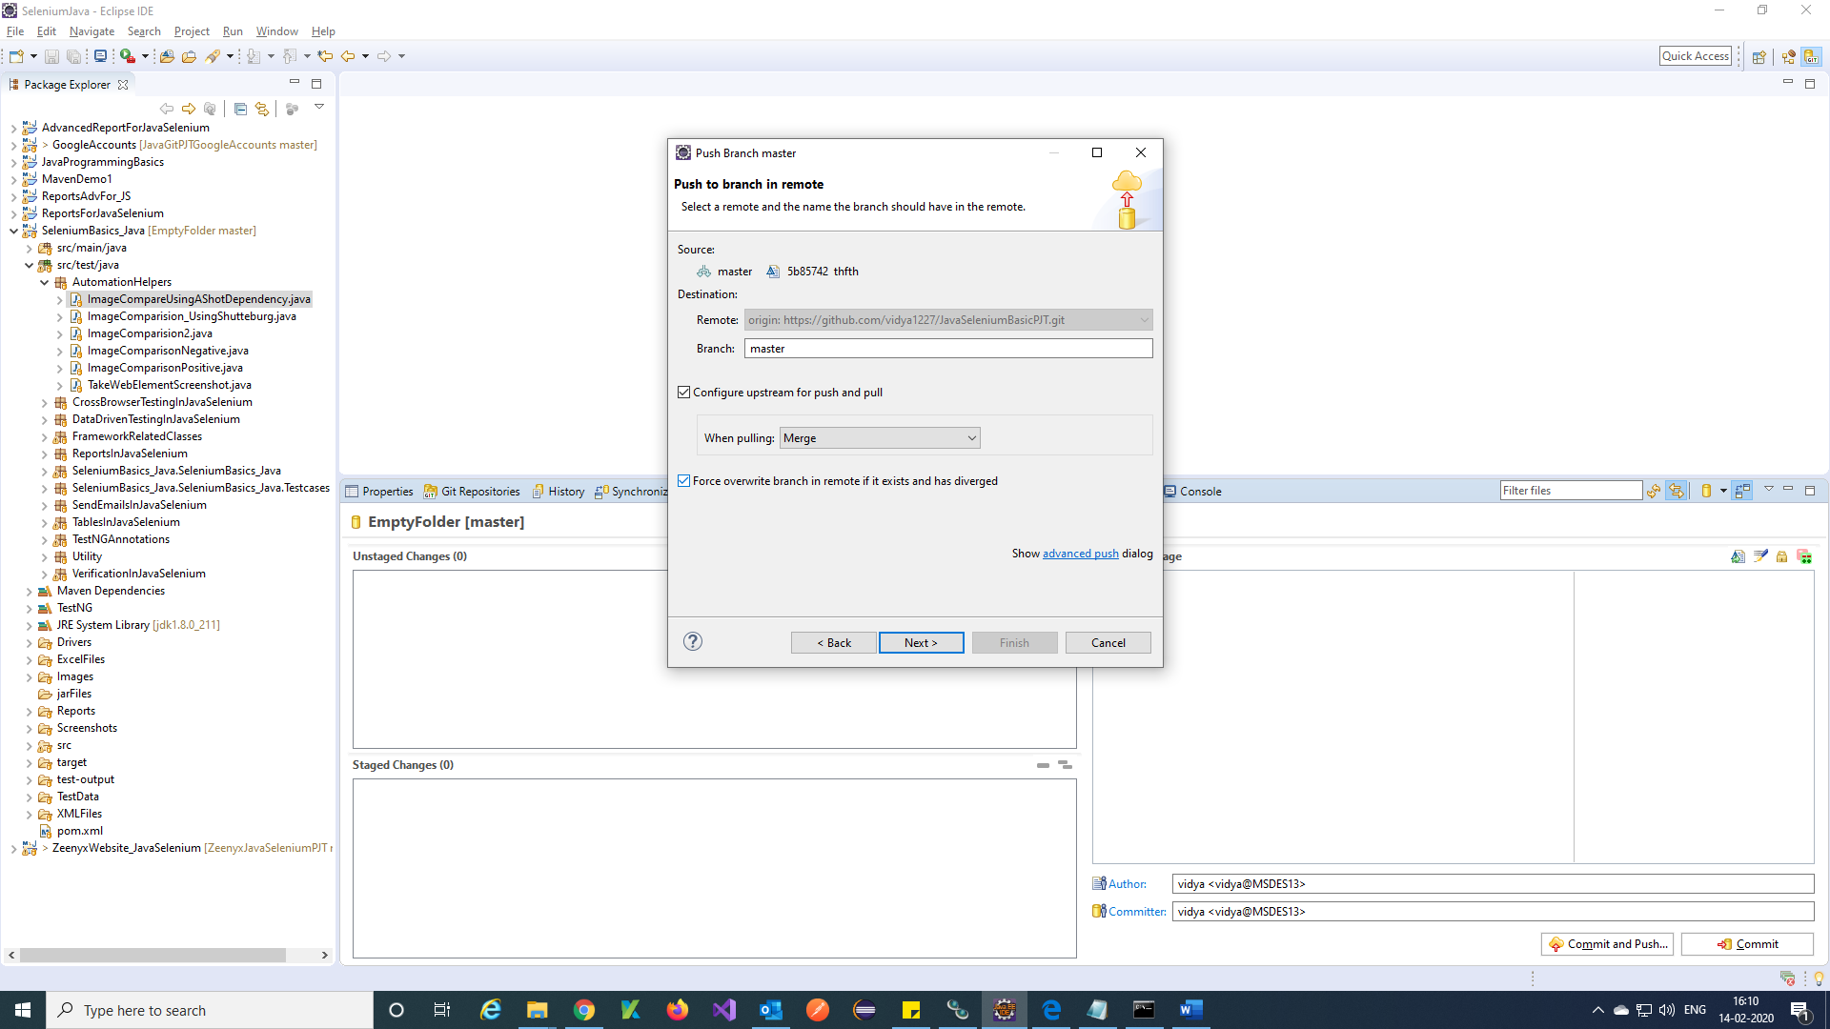

Step 11) Click on Finish.

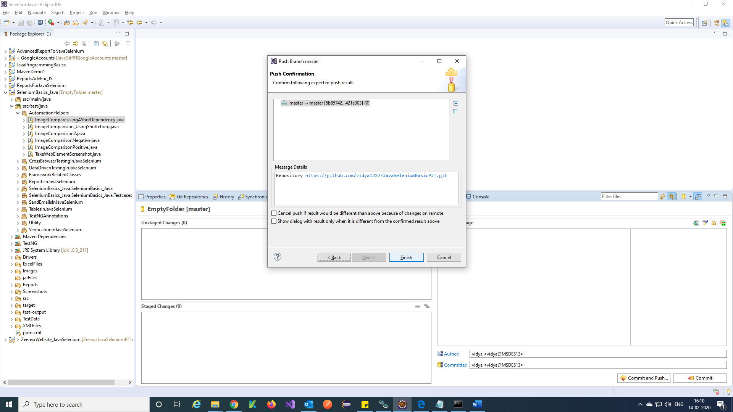

Step 12) Click on close.

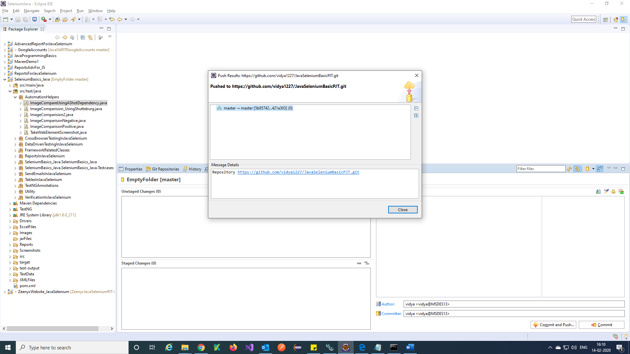

Step 13) Your project added successfully to Github.

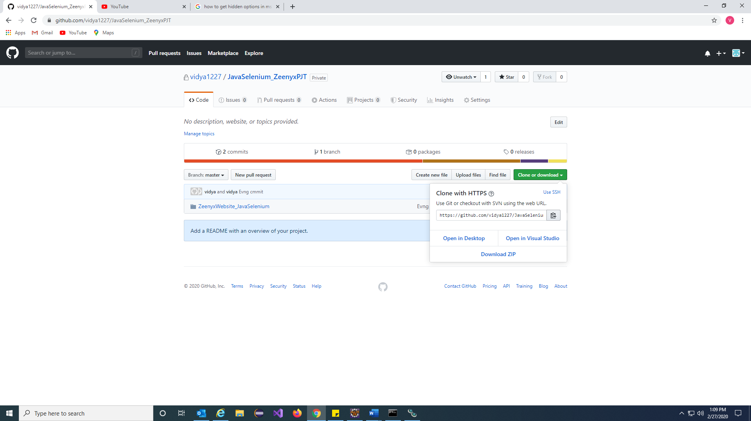

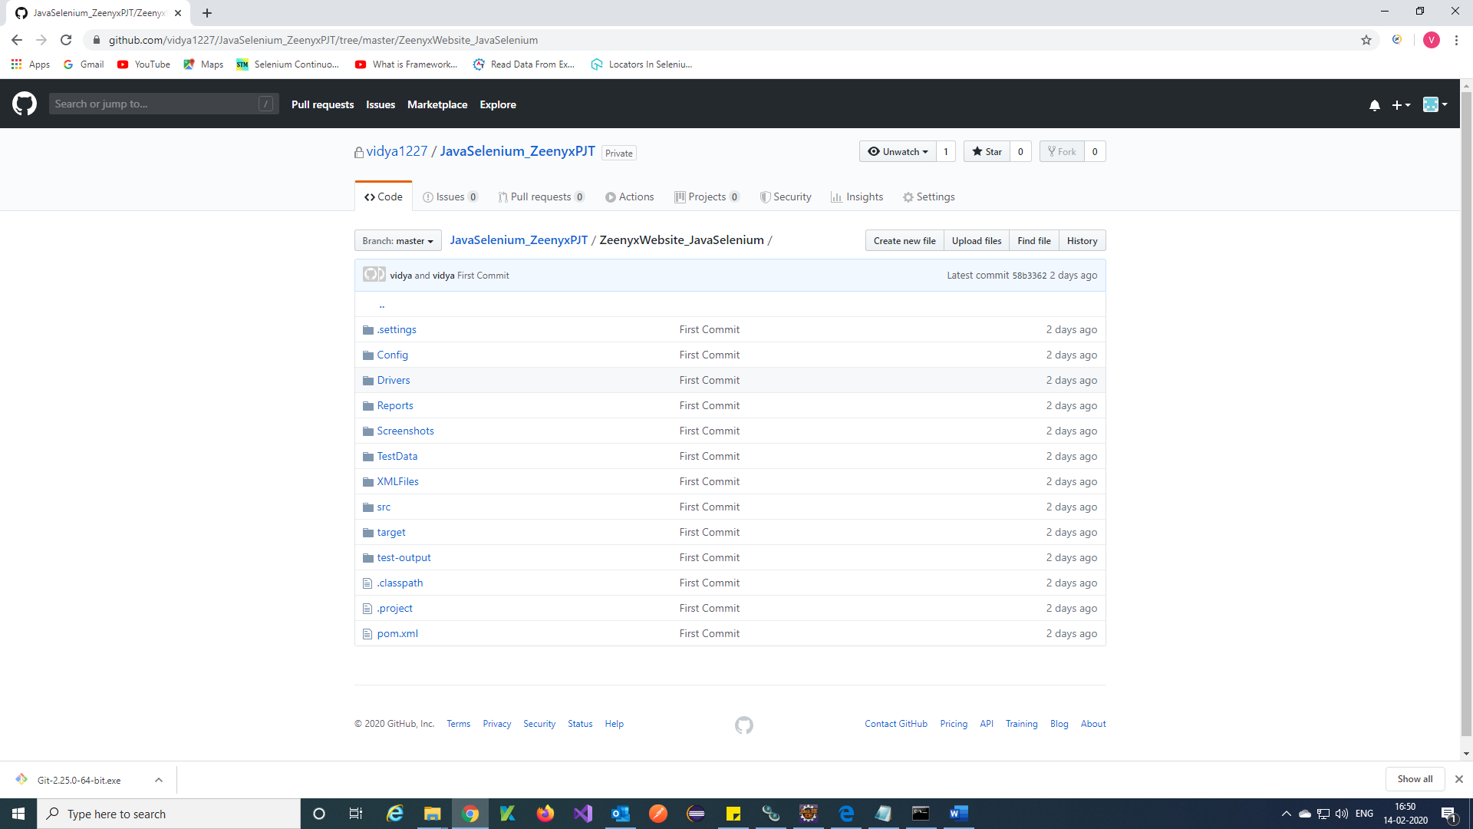

**Jenkins configuration for git project:**

Deploying command will be

Traverse to the folder location where the jenkins.war file is placed and run the below command in **Java –jar Jenkins.war**

command prompt. If you have not hosted any application on 8080 you can directly give the command as

**Or** to run on different port you can use the below command

**Java –jar Jenkins.war --httpPort=8088**

Once the Jenkins.war file is deployed successfully you can access Jenkins through the below URL.

<http://localhost:8088/>

Step 1) You will get this Jenkins home page.

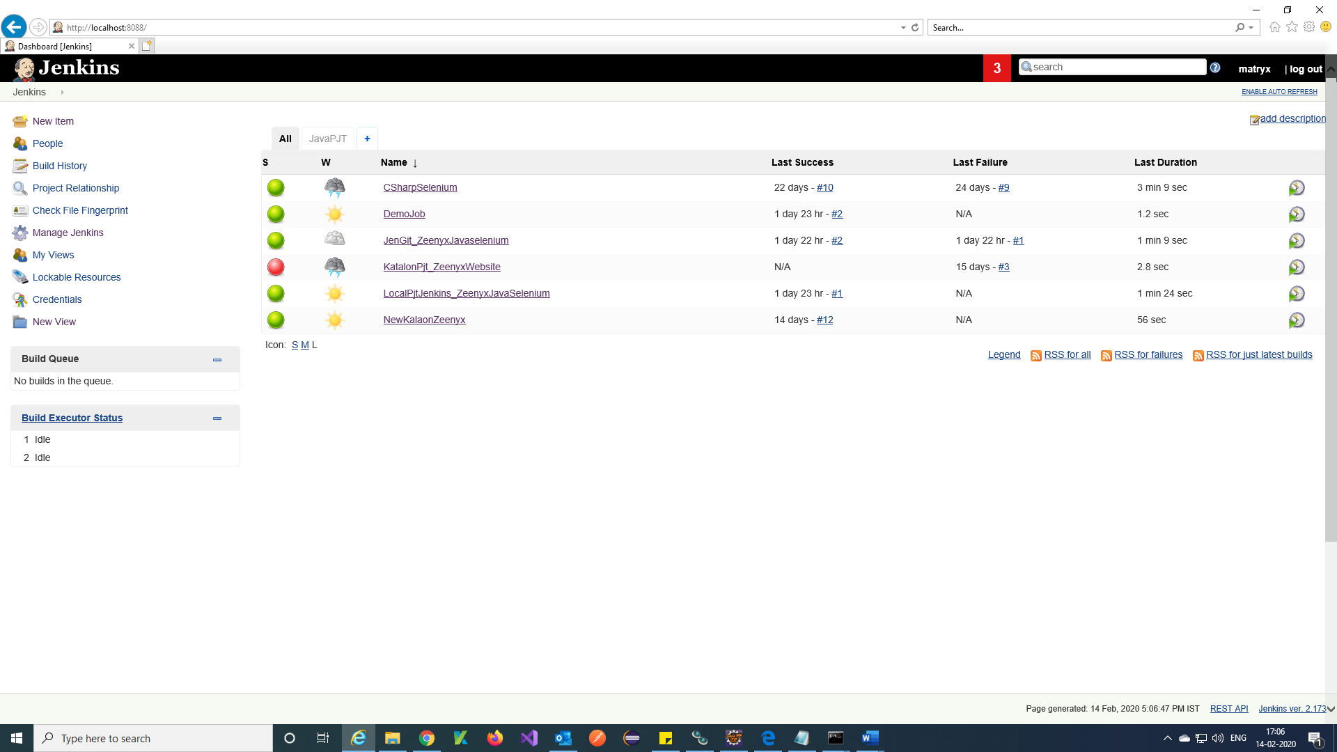

Step 2) Click on manage Jenkins 🡪 Global Tool Configuration 🡪 Add jdk bin path and Git exe path.

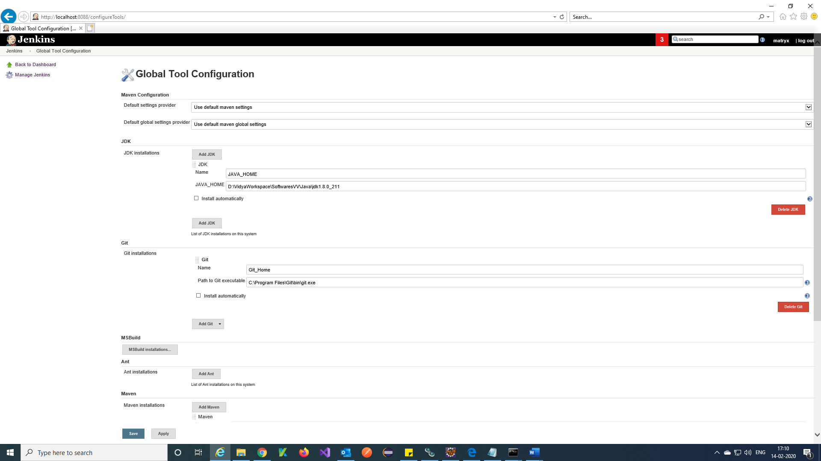

Step 3) And also add Apache maven path 🡪 Apply 🡪 Save.

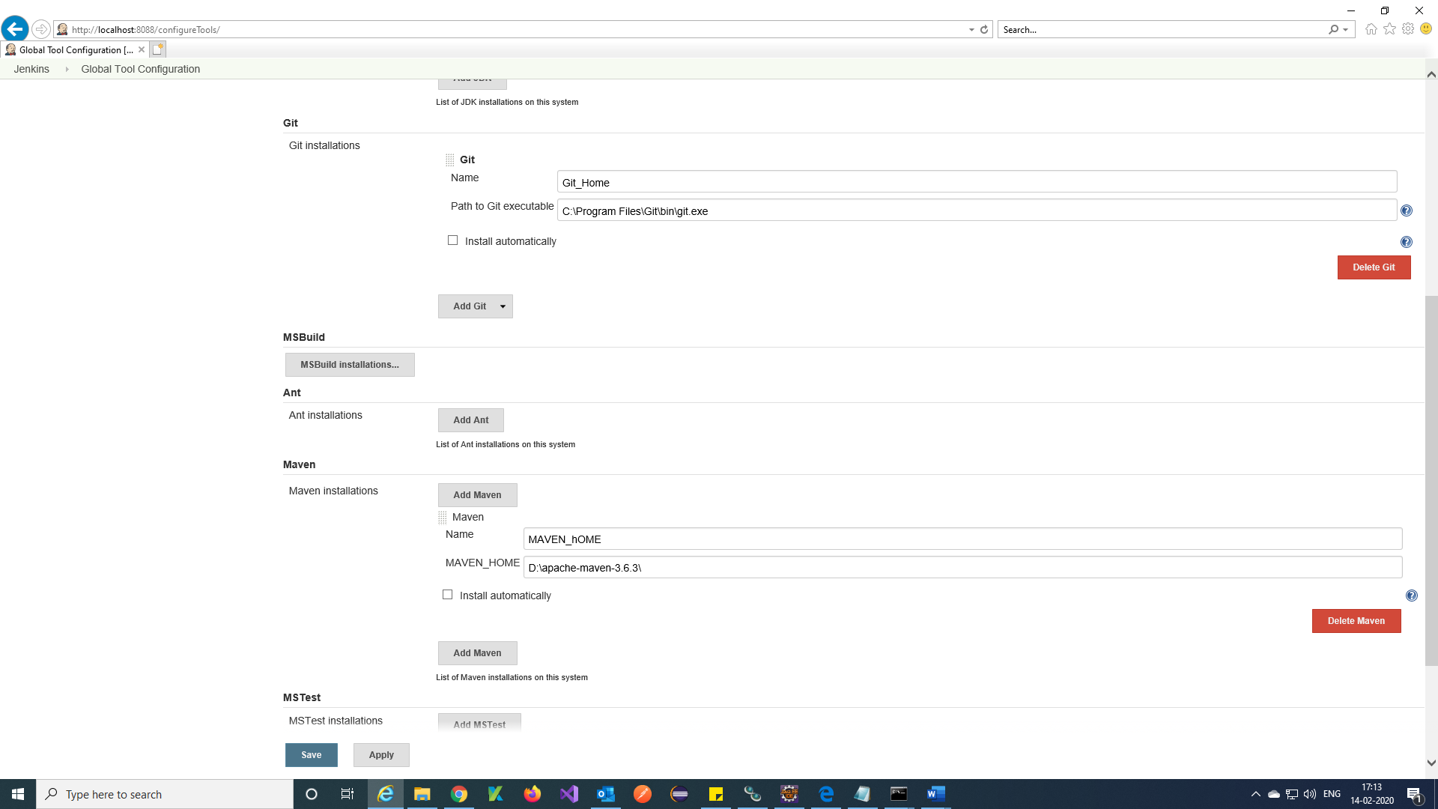

Step 4) Click on Manage Jenkins 🡪 Manage plugin 🡪 search for maven integration plugin in available and install.

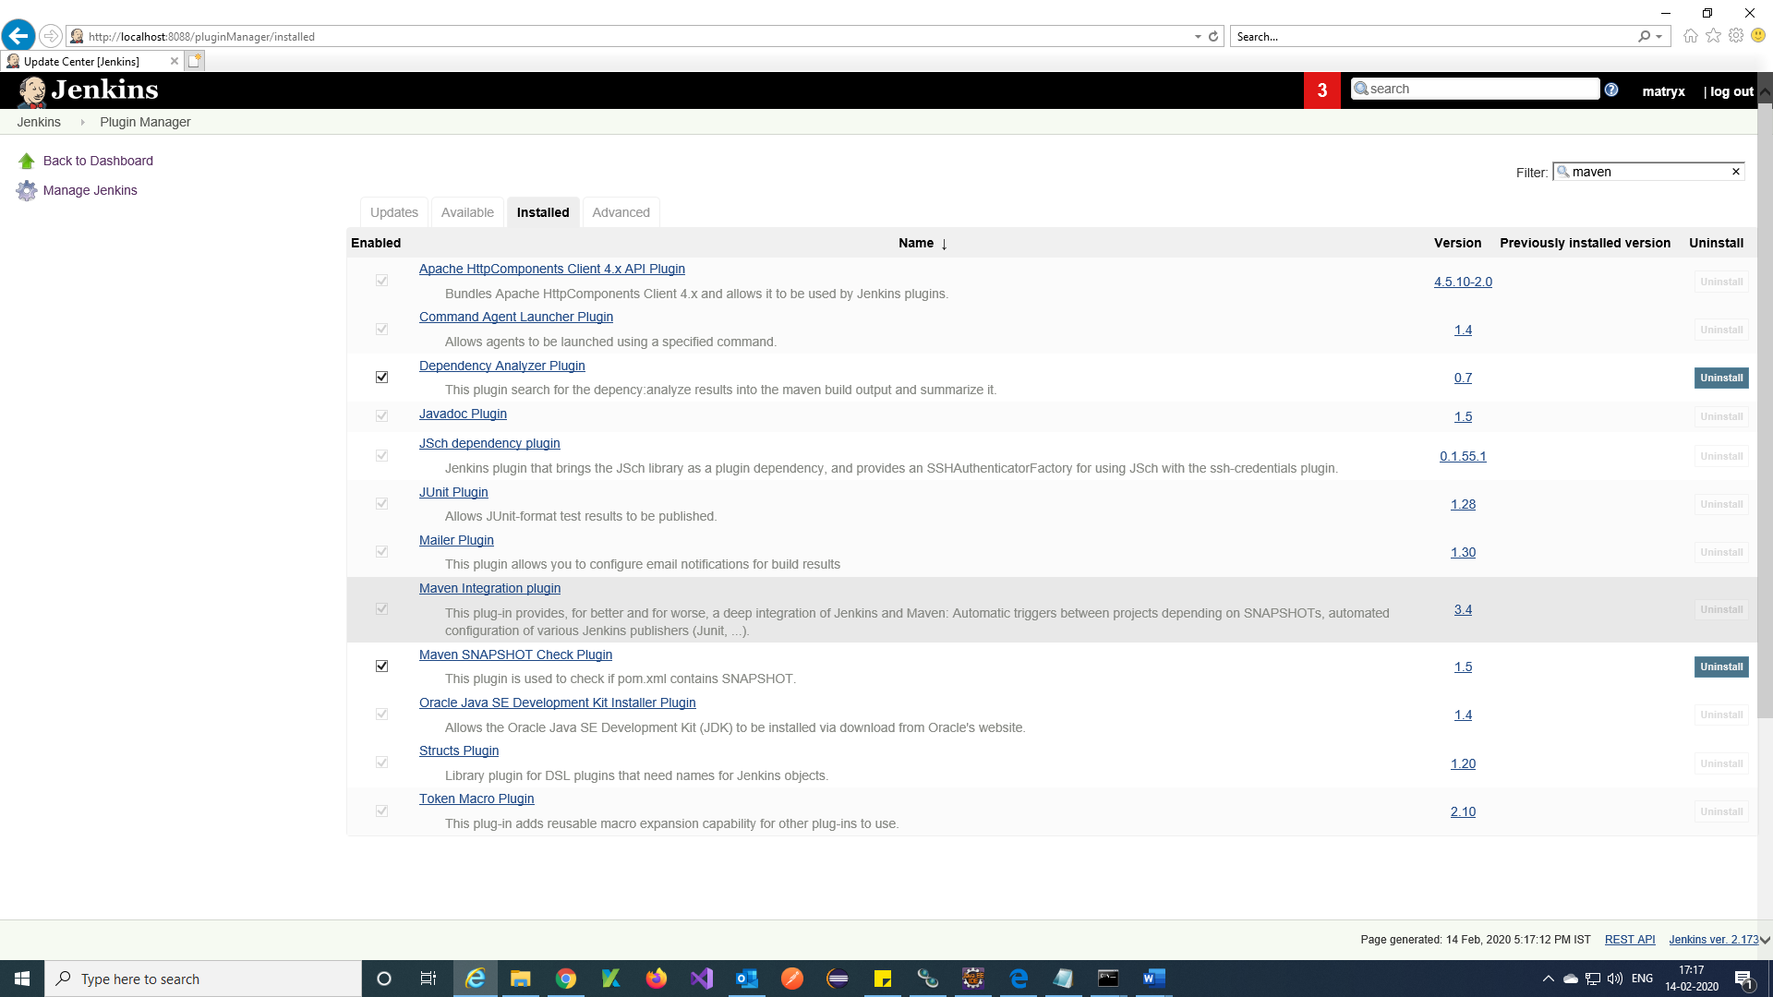

Note: If Maven Integration plugin is not installed means Download maven-plugin.hpi from google in prerequisites we mentioned URL to download plugin.

Step 5) Click on New Item 🡪 Enter an Item name 🡪 select Maven Project 🡪 Ok.

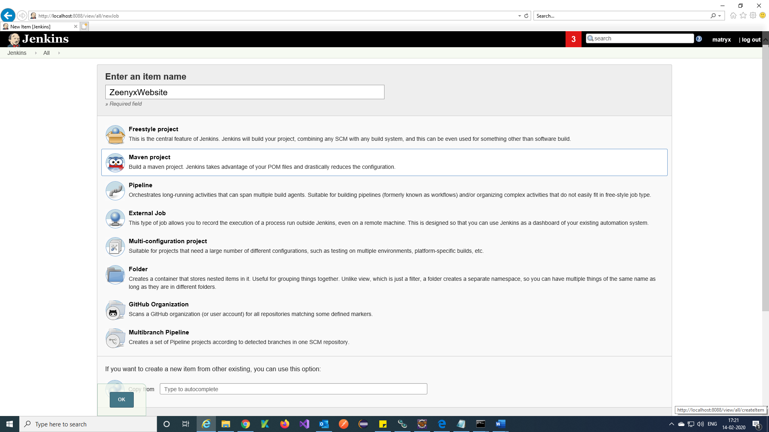

Step 6) Enter GitHub Repository URL and Credentials.

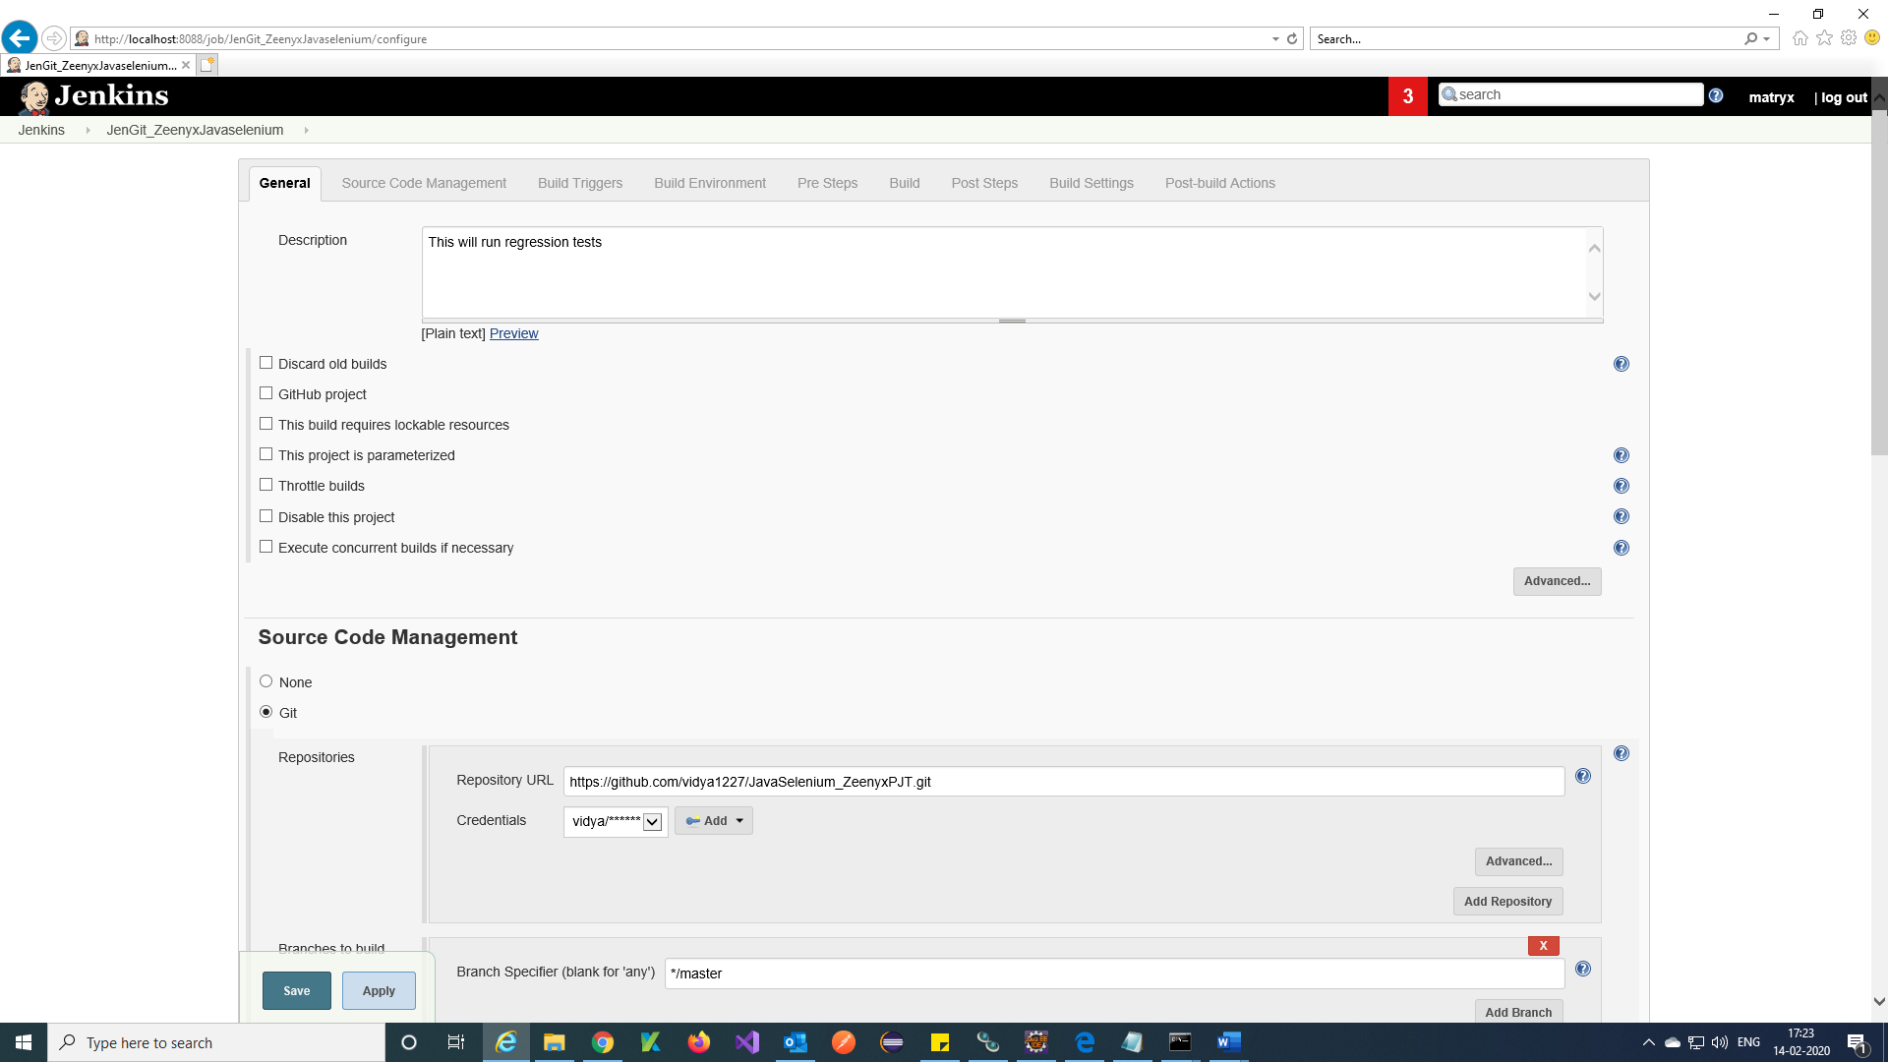

Step 7) Give your **Pom.xml** file path in Github and give command like **clean install 🡪**Save

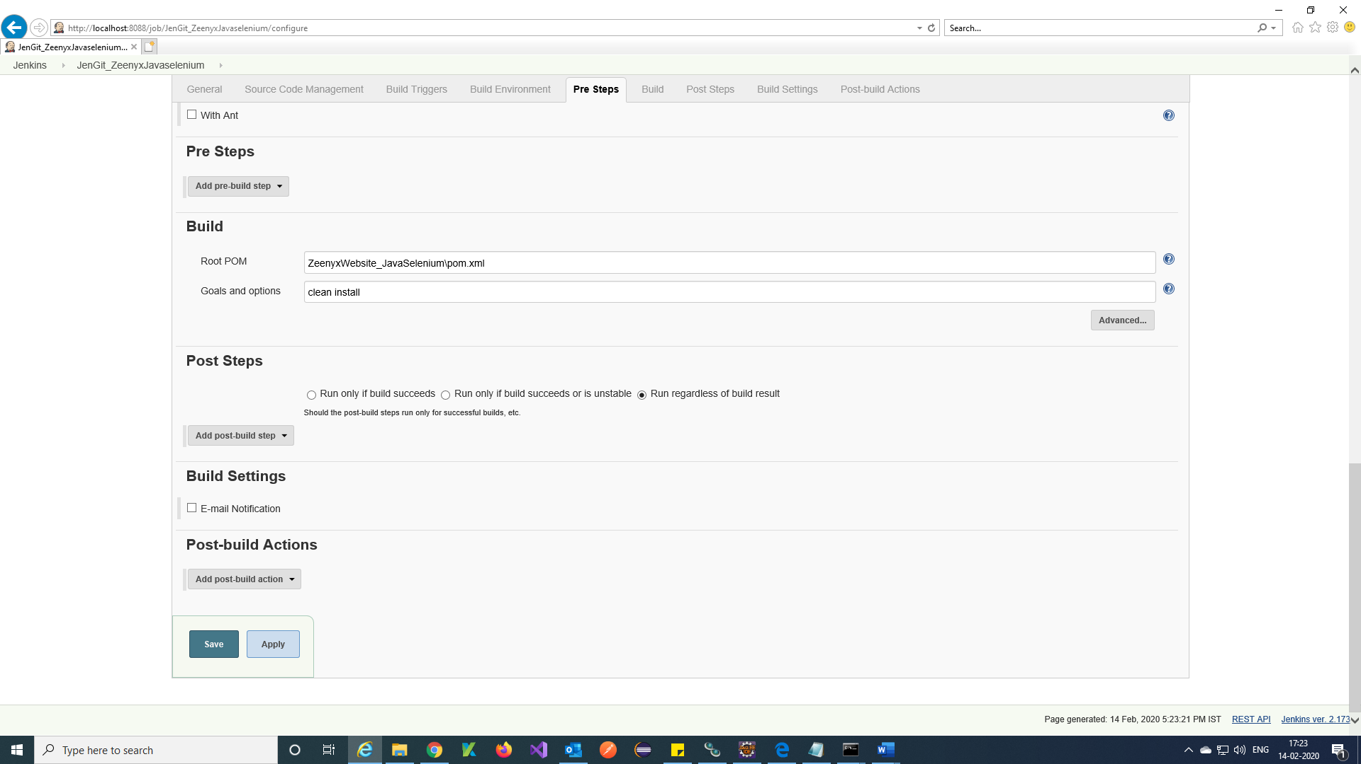

Step 8) Click on Build Now.

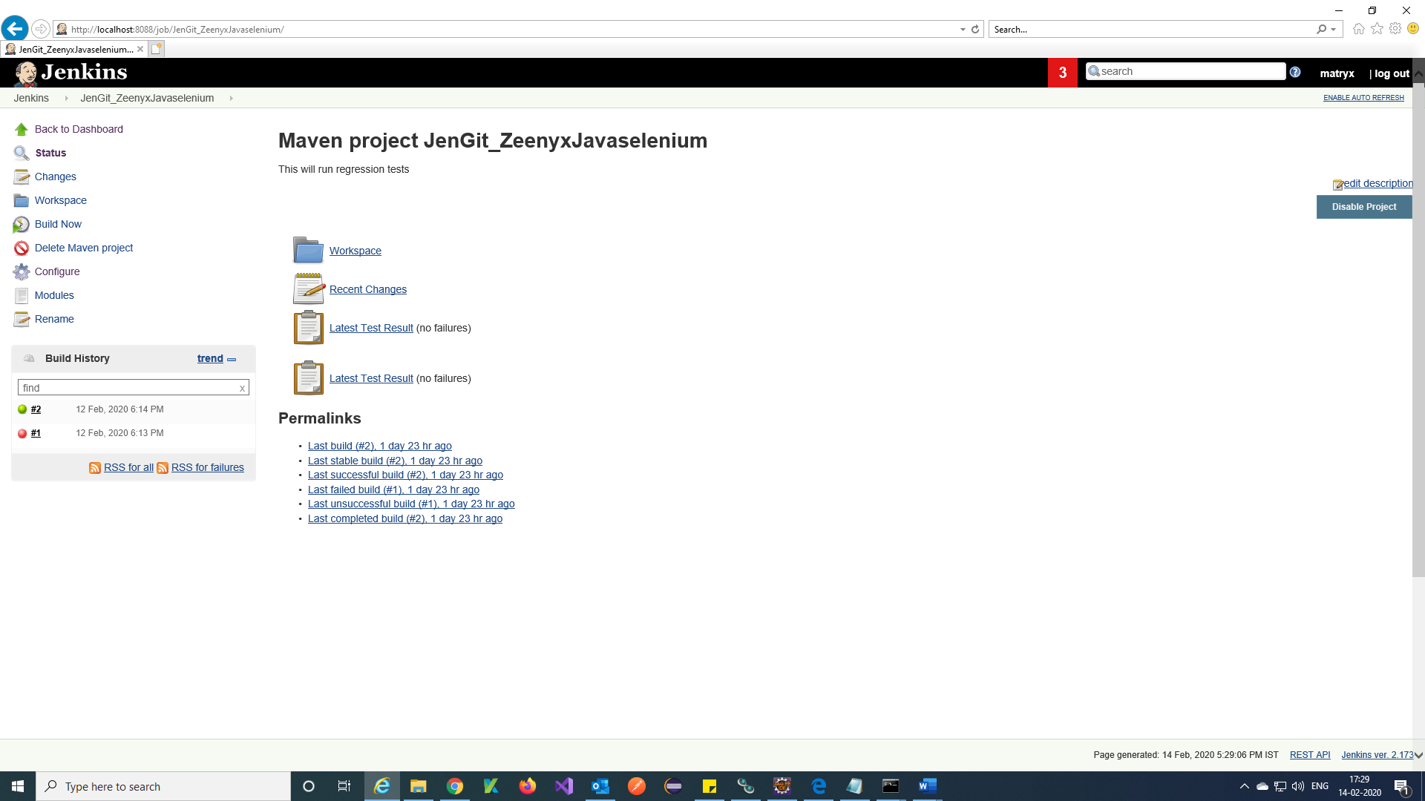

Step 9) You will get console output.

